**FTO Report**

**Party B: CRO Co.**

**New Antibody Service Using SMALP**

2023/11/11

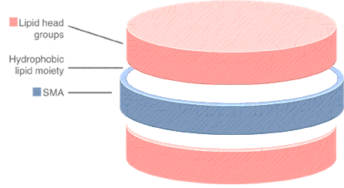

**Table of Contents**

Table of Contents1

Brief Summary2

Background2

Launch Status Assessment2

Technical Feature2

SMA Synthesis Protocol2

Protein Solubilization and Formation of SMALPS 3

Related Patents4

Patent 44

Patent 114

Patent 124

Related Patents5

Similar Proportion of Precursor Substances with Patent 45

Similar Surfactant HLB and Size of SMALP of Patent 115

No Methodological similarity with Patent 125

Conclusion of Infringement Comparison5

Risk Aversion Suggestions6

Similar Proportion of Precursor Substances with Patent 46

Similar Surfactant HLB and Size of SMALP of Patent 116

Conclusion6

References6

Total word count: **1482** with out table of content, figure, table and references.

**Brief Summary**

SMA copolymers also have a long-standing history in life sciences, originally being described as conjugates for drugs in cancer therapy (Maeda et al. 1979; Maeda 2001). Later, it was found that SMA can interact with phospholipids to form discoidal structures that can incorporate hydrophobic molecules and therefore would be useful as a drug delivery system (Tighe and Tonge 2000; Tonge and Tighe 2001). Based on this observation, new a.

**Background**

* 1. **Launch Status Assessment**

Object of this Freedom to Operate Report (FTO) is therapeutic antibody discovery services for membrane proteins using the technology of Styrene Maleic Acid Lipo-Protein (SMALP). The “*therapeutic antibody discovery services”* entrust us for this report is hereinafter referred to as **“*TADS”***.

Client in this case title of *CRO Co*., British organization *Contract Research Organization*. Potential market for this discovery service application is the UK market. Therefore, this FTO report will be written based on the principle of Section 60 of the *UK Patent Act.* Regarding the respect of infringement.

* 1. **Technical Feature**

**1.2.1** **SMA Synthesis Protocol**

Styrene–maleic acid (SMA) is the hydrolysed form of the styrene–maleic anhydride (SMAnh) copolymer in chemistry. When styrene(S) : maleic acid(Ma) molar ratio is 1:1, the reaction will generate SMA (see figure 1). Monomer sequence distribution in the polymer becomes more complex when S:Ma higher than 1:1 (Dorr et al. 2016).

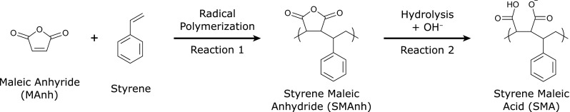

**Figure 1.** Synthesis of SMA (Dorr et al. 2016).

In scenario of *TADS*, precursor source will be come from commercially available acid anhydride period Netherlands *Inc. Polyscope* with a S: Ma ratio of is 3:1 (*Xiran* *®*). It should be mentioned that in the reference protocol of TADS, Lee’s team use S:Ma ratio 2:1 as SMALP using S:Ma ratio 3:1 precursor contains bilayers, and the synthesis also begin from acid anhydride period (Lee et al.2016a). Then they use basic hydrolysis to dissolve styrene maleic anhydride (SMAnh) copolymer in 1M NaOH and react under solution heating and reflux.

The hydrophilicity lipophilicity balance (HLB) is a wildly used parameter that determines the degree of hydrophilicity or lipophilicity by calculating the molecular weight percentage of the hydrophilic (*Mh*, molecular mass of the hydrophilic part) and lipophilic parts of the surfactant molecule. The equation is shown below where *M* means molecular mass of the whole particle (Griffin et al, 1946).

$$HLB=20*Mh/M$$

Activation of SMA in *TADS* results in SMA product with HLB of 16.5 and some other by-product (see chart 1). The production can be store as a light white powder (Lee et al. 2016a).

|  |  |
| --- | --- |
| **By-product Substance** | **Proportion by Weight** |
| free monomic styrene | 0.25% |
| free monomer maleic acid plus maleic anhydride | 0.3% |

**Chart 1.** By-Product and Proportion in Basic Hydrolysis Synthase of TADS

**1.2.2** **Protein Solubilization and Formation of SMALPS**

SMAs is used in a promising approach to detergent-free solubilize membrane proteins (MP). Most of the other processes to dissolve MB require detergents to extract native MPs from cellular membranes (Dorr et al. 2016). Detergents always cause transient destabilization of MP.

SMAs exhibit a significantly different mode of action from detergents. Addition of SMAs to synthetic or biological lipid membranes leads to the spontaneous formation of disc-shaped particles with a diameter of approximately 10 nm (Jamshad et al. 2015). In this novel SMAs bound nano disk, the bilayer structure of the incorporated lipid molecules is stabilized(Orwick et al. 2012). It had different names from different research at early stages, but nowadays most used name right now is SMALPs (see chart 2).

|  |  |
| --- | --- |
| **Name** | **Related Research** |
| SMA–lipid particles (SMALPs) | Knowles et al. 2009 |
| Lipodisq particles | Orwick et al. 2012 |
| native nanodiscs | Dörr et al. 2014 |

**Chart 2.** Other names for the particles and related publication

Add powdered SMA polymer to membrane solution at a ratio of 1g:10g (Lee et all. 2016a), MP with up to 36 transmembrane domains will spontaneously form a 9-12nm diameter SMALP structure (Orwick et al. 2012; Knowles et al. 2009). Research proved that protein structure remained stable in SMALP. After that protein can still be purified directly by wildly used methods such as chromatography (Scheidelaar et al.2015; Dorr et al. 2016).

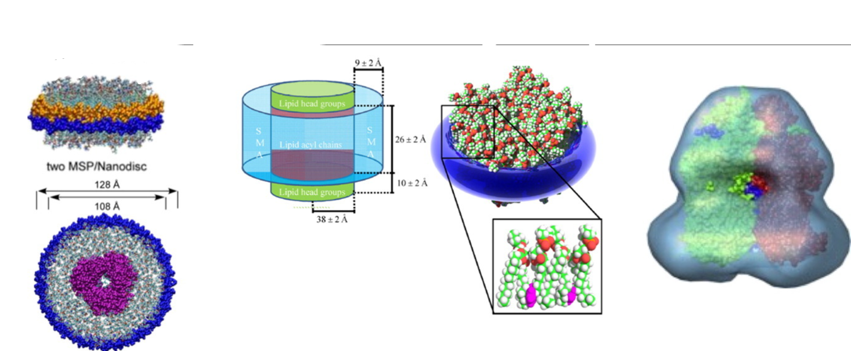

**Figure 2.** Comparison of membrane proteins in nano-discs. Shows MSP, lipid only SMALP, egative stain 3D reconstruction of SMALP from left to right (Lee et all. 2016b).

**Related Patents**

The search was conducted by a professional patent search company in PatBase. The most relevant from this comprehensive patent search are 3 patents (assumingly) granted in UK shown below.

**2.1 Patent 4**

WO2011/004158,

SOLUBILISATION OF MEMBRANE PROTEINS

This patent is published on 13 January 2011. It focusses on method to solubilise a membrane protein.

This method is applied to molecular in cell membrane including proteins and related lipids. It is done by mixing copolymer of 1:2 to 10:1 styrene and maleic acid, with cellular component to form soluble macromolecular assemblies of the copolymer, lipids, and proteins.

What we need to remind to Party B is that the invertor of this patent is Tim Dafforn. Tim Dafforn is the corresponding author of the journal article from Nat Protocol “A method for detergent-free isolation of membrane proteins in their local lipid environment” (see Lee et al, 2016a), which Party B is referencing their protocol. We will mention later that the synthesis method of Lee’s article, which is the method being used by party B in TADS, is indeed include in the patent 4.

**2.2 Patent 11**

*WO2008/065451,*

*COMPOSITIONS COMPRISING MACROMOLECULAR ASSEMBLIES OF LIPID AND SURFACTANT*

This patent is published on 5 June 2008. It is the originally patent of *SAMLP* although name of it is *Lipodisq*represent in the document.

It provides composition comprising lipids and surfactants. The surfactant in it has an HLB number of less than 20. The lipids and surfactants form the less than 100nm macromolecular assemblies.

**2.3 Patent 12**

*WO2007/115165*

*STYRENE-MALEIC ANHYDRIDE COPOLYMERS FOR BIOAPPLICATIONS AND THEIR PREPARATION*

This patent is published on 11 October 2007. It focusses on the solvent free technology to prepare SMA.

It is mentioned that solvent-free method results in a reduction in the amount of residue, such as unreacted styrene and/or maleic anhydride monomers, making copolymers particularly suitable for biological applications.

**Infringement Comparison**

**3.1** **Similar Proportion of Precursor Substances with Patent 4**

TADS used precursor of S:Ma=3:1 which infringe the property right of Patent 4.Patent 4 emphasized that all copolymer of styrene and maleic acid used in membrane protein solubilising wherein the styrene : maleic acid ratio is between 1:2 and 10:1 is against their claim 1.

**3.2 Similar Surfactant HLB and Size of SMALP of Patent 11**

In claim 1 of Patent 11 confirm that all SMALP characterised in that the surfactant has an HLB number of less than 20 and in that the lipid and surfactant are in the form of macromolecular assemblies of less than 100 nm in diameter. TADs represent a surfactant HLB of 16.5 and Assembly Size of about 10 nm, which constitute infringement of patent 11.

3.3 No Methodological similarity with Patent 12

3.4 Conclusion of Infringement Comparison

|  |  |  |  |  |  |  |  |  |  |
| --- | --- | --- | --- | --- | --- | --- | --- | --- | --- |
|  | Possible Infringement Aspects | | | | | | | | |
| SMA Synthesis Method | IN | S: MA Ratio | IN | Surfactant  HLB | IN | Assembly Size | IN | Final |
| TADS | Basic Hydrolysis Protocol | - | 3:1 | - | 16.5 | - | ~10nm | 5 |
| Patent  4 | Basic Hydrolysis Protocol | N | 1:2 to 10:1 | Y | - | N | - | N | Y |
| Patent 11 | - | N | - | N | >20 | Y | >100nm | Y | Y |
| Patent 12 | Solventless Method | N | - | N | - | N | - | N | N |

Chart

**Risk Aversion Suggestions**

4.1

Conclusion

Reference